**A**

**PROJECT SYNOPSIS**

**ON**

" **EMPLOYEE TRACKING SYSTEM** "

**SUBMITTED TO**

**SHIVAJI UNIVERSITY, KOLHAPUR**

**For partial fulfillment of**

**“Bachelor of Computer Application”**

**SUBMITTED BY**

**MR. SHUBHAM SHIVAJI MENGANE.(B.C.A –III)**

**MR. OMKAR SURESH GAVALI.(B.C.A –III)**

**UNDER THE GUIDANCE OF**

**Asst. Prof. Miss D. S. Mahajan(Msc.cs)**

**THROUGH**

**The Principal**

**SHIVRAJ COLLEGE OF ARTS , COMMERCE & D.S.KADAM**

**SCIENCE COLLEGE, GADHINGLAJ DIST.KOLHAPUR**

**2022 – 2023**

K.V.R.S.S.S’s

SHIVRAJ COLLEGE OF ARTS, COMMERCE & D.S.KADAM SCIENCE COLLEGE, GADHINGLAJ DIST. KOLHAPUR



CERTIFICATE

This is to certify that ,

1.Mist. Shubham Shivaji Mengane.

2.Mist. Omkar Suresh Gavli.

Have successfully completed the project on the topic " **EMPLOYEE TRACKING SYSTEM**” in satisfactory manner for partial fulfillment of Bachelor Of Computer Application (BCA) degree for the academic year 2021-23.

To the best of our knowledge and belief, the matter presented here is original and has not been submitted elsewhere for the award of any degree.

Date: / /2022

Place: Gadhinglaj

H.O.D

Asst. Prof. K.S.Desai

EXAMINER

Project Guide

Asst. Prof. Miss D. S. Mahajan(Msc.cs)

### K.V.R.S.S.S’s

**SHIVRAJ COLLEGE OF ARTS, COMMERCE & D.S.KADAM SCIENCE COLLEGE, GADHINGLAJ DIST. KOLHAPUR**

GUIDANCE

This is to certify that the project entitled " **EMPLOYEE TRACKING SYSTEM**” conducted at Shivraj College Gadhinglaj by

Mist. Shubham Shivaji Mengane. and Mist. Omkar Suresh Gavli.

In partial fulfillment of this work for award of Bachelor of Computer Application submitted to Shivaji University , Kolhapur has been completed under my supervision and guidance.

To the best of my knowledge and belief, the presented by them is original in nature and has not been from any source. In addition, this report has not been submitted earlier for ant degree or diploma of Shivaji University or any other university.

Place : Gadhinglaj.

(Project Guide)

Asst. Prof. Miss D. S. Mahajan

Date :

CERTIFICATE

" **EMPLOYEE TRACKING SYSTEM**”

This is to certify that Mist. Shubham Shivaji Mengane. and Mist. Omkar Suresh Gavli. The students of Shivraj College ,Gadhinglaj have developed this project report entitled " EMPLOYEE TRACKING SYSTEM” for our institute.

The data collected and processed is according to our requirement of system .Their work is upto the mark of satisfaction and that was good.As per my knowledge it is their original work and it is carried out very much sincerely.

I wish that all success in their future

Place: Gadhinglaj

Date:

DECLARATION

We undersigned hereby declare that this report entitled " **EMPLOYEE TRACKING SYSTEM**” for Shivraj College of Arts, Commerce and D.S. Kadam Science college , Gadhinglaj, is our original work prepared under guidance of Asst. Prof. Miss D. S. Mahajan. The Empirical finding in this report are based on data collected by us. The matter presented is this report is not copied from any source.

We understand that such copy is liable for punishment in any way the university Authorities deem to fit. This work has not been submitted to either Shivaji University or any other University.

This work is humbly submitted to Shivaji University ,Kolhapur for the award of the degree of Bachelor of Computer Application

Place : Gadhinglaj Mist. Shubham Shivaji Mengane.

Date: Mist. Omkar Suresh Gavli.

ACKNOWLEDGEMENT

It gives great pleasure to remain deeply indebted to our guide Asst. Prof. Miss D. S. Mahajan for providing us with the required facilities for the academic achievement under whom we had the privilege to work. The faith and Confidence shown by him in us boosted our moral and motivated us to perform better in preferring this project.

We are thankful to those who have contributed either directly or indirectly to this project.

Thanking You.

Mist. Shubham Shivaji Mengane.

Mist. Omkar Suresh Gavli.

INDEX

|  |  |  |
| --- | --- | --- |
| **Sr. No** | **Contents** | **Page No.** |
| **1** | **Introduction** | **8** |
| **2** | **Organization Profile** | **10** |
| **3** | **About Project :**   * Existing Manual System & Limitations * Proposed System * Objectives of Proposed System * Methodology * Advantages of Proposed System | **11 – 15** |
| **4** | **System Analysis**   * System Development Life Cycle | **16** |
| **5** | **System Design**   * DFD * ERD | **17 – 22** |
| **6** | **System Requirement** | **23** |
| **7** | **About Java** | **24 – 27** |
| **8** | **About SQL Database** | **28 – 31** |
| **9** | **Database Design** | **32 – 35** |
| **10** | **Source Code** | **36 – 41** |
| **11** | **Output Design**   * Homepage | **42 – 49** |
| **12** | **Reports**   * Reports | **50 - 52** |
| **13** | **Conclusion**   * Limitations * Conclusions | **53-54** |
| **14** | **Bibliography** | **55** |

# ***INTRODUCTION***

Introduction

This Project is mainly developed by using “NETBEANS IDE, SQL Server”.

Employee Tracking System is a program to automate or computerize all employee Tracking operations.

Employee Tracking System is open to admins, Managers, and regular employees. Among all users, only the admins have all privileges to access all the information of Employee Tracking System. So the admins will insert, update, remove the employees, departments, generate reports and whereas other users will have limited roles. Once the user’s login they can perform few tasks specific to their role.

Such as Managers can update a project report and give rating to employee working on that project.

Employee can also update there work done on the project and they can also apply for leave.

ORGANIZATION PROFILE

**Organization Name:** Developers End

**Venue:** Gadhinglaj

**Contact No.: 02312468383**

**Area of work:** Gadhinglaj

**Owner: Mr. Omkar Gavli**

EXISTING SYSTEM

* In existing system for maintaining attendance there are registers but they are not properly managed there are many chances of mistakes or miss-attendance.
* The existing employee management system in the organization still uses the ordinary classical methods which are merely based on pen-paper to record the data of their employees.
* Large quantities of registers are to be maintained for this purpose which results in downright waste of time in generating reports or searching for employee’s records and loss of data if any file is lost.
* It is also an arduous task for organizations as it is an expensive process.

Objectives

* The main objective of the application is to maintain the details of employees.
* The employee tracking system project is to create a user-friendly software application that efficiently manage employee-related data such as attendance, leave performance evaluation etc.
* The system allowing admin and manager to monitor their work progress and performance.
* The system should also generate the reports which helps the manager to know about their employee work and project progress.
* Ultimately, the main goal of this project is to improve organization efficiency and good and transparent data management.

Proposed System

* It allows managers to monitor the progress of work.
* It allows manager to evaluate employee performance and give rating to them.
* It allows the employee to apply for leave.
* It allows update the work done of project and generate report.
* It allows central database that contains information about each employee, including their name, contact information, job title, department, and other relevant data.
* The system Gives the strong security features to protect employee data and prevent unauthorized access.
* It allows to track employee performance metrics such as productivity, quality of work, and attendance.

Methodology

For designing a computerized system we have been followed the software engineer approach for developing the software .We have choosed the classic life cycle approach for developing the software development which is SDLC .This includes system design ,system analysis and testing which is followed by again first phase i.e.repeating the cycle.

System desing means understand the old system completely and planning the old system completely and planning the new system or to replace existing system .

Then we tell them that we are making project on online " EMPLOYEE TRACKING SYSTEM”. So they give us information like Employee Attendance, Employee Registration and required report and over all process. They told us how the existing system is working.

After getting all needed information we make design of the " employee tracking system” as per we planned.

We get help for staff of computer application at coding time of the project . They support us very well . for giving the demo we use some customers for the betterment of our software.

ADVANTAGES OF PROPOSED SYSTEM

* Allows managers to monitor the progress of work.
* Allows manager to evaluate employee performance and give rating to them.
* Allows the employee to apply for leave.
* Allows update the work done of project and generate report.
* Allows to track employee performance metrics such as productivity, quality of work, and attendance.

System Analysis & Life Cycle

#### THE PROCESS MODEL USED FOR THE SYSTEM:

The process model used for this system “Classic Life Cycle”as this is simple and is best for small scale project.

The “Classic Life Cycle” is also called System Development Life Cycle (SDLC). It is defined “The growth of an information system is through various identifiable stages. These stages are grouped together and referred as SDLC.” The structure of its stages which we used in our project is as follows:

Waterfall model



**Testing**

**Code**

**Design**

**Analysis**

**System**

**Maintenance**

**DATA FLOW DIAGRAM (DFD)**

CONTEXT LEVEL DIAGRAM

User

Admin

0.0

Management System

Getting information

Managing the project information

Adding Employees Managers Project

Provide the form

Sign Up

Submit form

User

Admin

Provided

form

**ERD diagram for mobile shop management system.**

**ERD diagram for mobile shop management system.**

Logging in

Provided All Data

Access All Data

Provide all information about daily work

EMPLOYEE TRACKING SYSTEM

Login

Logging in

Provided Information

Adding Attendance

**ENTITY RELATIONSHIP DIAGRAM (ERD)**

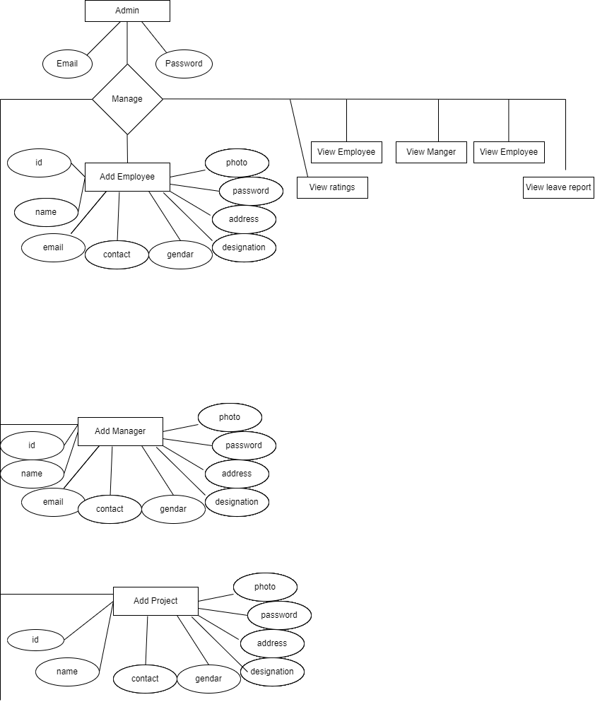

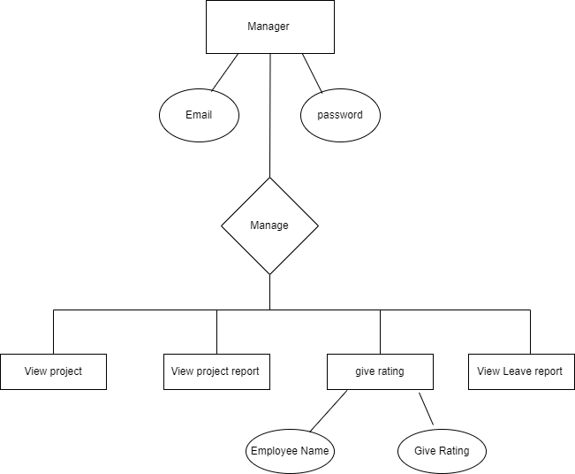

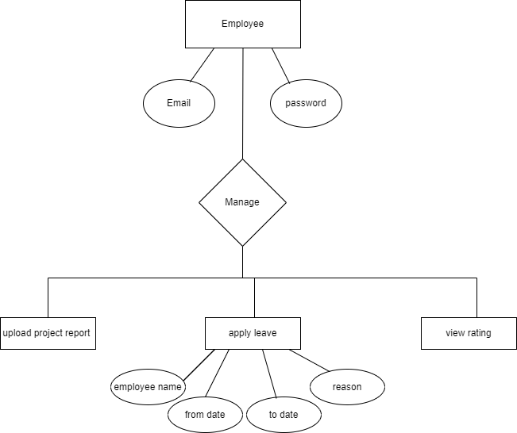

**SYSTEM**

**REQUIREMENT**

* :**Software Requirement:**

• JDK (Net beans IDE 7.2)

• MY-SQL workbench

• Glassfish server 3.1

• Jasper Report 5.1

• Operating System:-Windows-7 64 bit.

* + - **Hardware Requirement:**
* Intel Dual Core or Higher Processor.
* GB of RAM or Above.
* Minimum 20 GB Hard-Disk
* 1 Keyboard and Mouse

**ABOUT JAVA**

About Java

Java is an object-oriented programming language developed by James Gosling and Colleagues at Sun Microsystem in early 1990s. Unlike conventional languages which are generally designed either to be compiled to native code, or to be interrupted from source code at runtime, Java is intended to be compiled to a byte code, which is then run (generally using JIT compilation) by a Java Virtual Machine.

Java was started as a project called “oak” by James Gosling in June 1991. Gosling goals were to implemented a virtual machine and a language that had a familiar C-like notation but with greater uniformly and simplicity then C and C++. The first public implementation was Java

* 1. in 1995. It made the promise of “Write Once, Run Anywhere”, with free runtimes on popular platforms. It was fairly secure and its security was configurable, allowing for network and access to be limited. The major web browsers soon incorporated it into their standard configuration in secure “Applet” configuration popular quickly. New versions for large and small platforms (J2EE and J2ME) soon were designed with the advent of “Java 2”. Sun has not announced any plans for a “Java 3”.

About Java NetBeans(IDE)

The Net Beans Platform is a framework for simplifying the development of Java Swing desktop applications. The Net Beans IDE bundle for Java SE contains what is needed to start developing Net Beans plugins and Net Beans Platform based applications no additional JDK is required.

Applications can install modules dynamically. Any application can include the Update Centre module to allow users of the application to download digitally signed upgrades and new features directly into the running application. Reinstalling an upgrade or a new release does not force users to download the entire application again.

The platform offers reusable services common to desktop applications, allowing developers to focus on the logic specific to their application. Among the features of the platform are:

Net Beans IDE is an open-source integrated development environment. Net Beans IDE supports development of all Java application types (Java SE (including Java FX), Java ME, web, EJB and mobile applications) out of the box. Among other features are an Ant-based project system, Maven support, refactoring, version control (supporting CVS, Subversion, Mercurial and Clear case).

Modularity: All the functions of the IDE are provided by modules. Each module provides a well-defined function, such as support for the Java language, editing, or support for the CVS versioning system, and SVN. Net Beans contains

all the modules needed for Java development in a single download, allowing the user to start working immediately. Modules also allow Net Beans to be extended. New features, such as support for other programming languages, can be added by installing additional modules. Forinstance, Sun Studio, Sun Java Studio Enterprise, and Sun Java Studio Creator from Sun Microsystems are all based on the Net Beans IDE.

**License :** From July 2006 through 2007, Net Beans IDE was licensed under Sun's Common Development and Distribution License (CDDL), a license based on the Mozilla Public License (MPL). In October 2007, Sun announced that Net Beans would henceforth be offered under a dual license of the CDDL and the GPL version 2 licenses, with the GPL linking exception for GNU Class path

* User Interface Management (e.g. Menus and Toolbars)
* User Settings Management
* Storage Management (Saving and Loading any Kind of Data)
* Window Management
* Wizard Framework (Supports Step-by-Step Dialogs)
* Net Beans Visual Library
* Integrated Development Tools

**ABOUT SQL DATABASE**

What is Database?

A database is a separate application that stores a collection of data. Each database has one or more distinct Application for creating, accessing managing, searching and replicating the data it holds.

Other kinds of data stores can be used such as files on the file system or large hash tables in memory but data fetching and writing would not be fast and easy with those types of systems.

So now a day we use relational database management systems (RDBMS) TO store and manage huge volume of data. This is called relational database because all the data is stored into different bales and relations are established using primary keys or other keys known as foreign keys.

Relational Database Management System

(RDMS)

* Enables you to implement a database with tables, columns and indexes.
* Guarantees the Referential Integrity between rows of various tables.
* Updates the indexes automatically.
* Interprets a SQL query and combines information from various tables.

MySQL Database

MySQL

* MySQL is a fast, easy-to-use RDBMS being used for many small and big businesses. SQL was initially developed at IBM by DONALD Chamberlin and Raymond Boyce after learning about the relation model from Ted Cod in the early 1970 s.:
* MySQL is released under an open-source license. So you have nothing to pay to use it.
* MySQL is a very powerful program in its own right. It handles a large subset of the functionality of the most expensive and powerful database packages.
* MySQL uses a standard form of the well-known SQL data language.
* MySQL works on many operating systems and with many languages including PHP, PERL, C, C++, JAVA, etc.
* MySQL works very quickly and works well even with large data sets.
* MySQL is very friendly to all language, the most appreciated language for web development.
* MySQL supports large databases, up to 50 million rows or more in a table. The default file size limit for a table is 4GB, but you can increase this (if your operating system can handle it) to a theoretical limit of 8 million terabytes (TB).

**DATABASE DESIGN**

Employee Registration :

|  |  |  |
| --- | --- | --- |
| Column Name | Data Type | Description |
| Name | Varchar(50) | To Store Name |
| Phone | Bgint(10) | To Store Mobile Number |
| Email | Varchar(50) | To Store Email Address |
| Address | Varchar(50) | To Store Address |
| Dob | Varchar(50) | To Store Date Of Birth |
| Password | Varchar(50) | To Store Password |
| Gender | Varchar(50) | To Store Gender |
| Design | Varchar(50) | To Store Designation |
| Img | Blob(500) | To Store Photo |

Manager Registration :

|  |  |  |
| --- | --- | --- |
| Column Name | Data Type | Description |
| Name | Varchar(50) | To Store Name |
| Phone | Bgint(10) | To Store Mobile Number |
| Email | Varchar(50) | To Store Email Address |
| Address | Varchar(50) | To Store Address |
| Dob | Varchar(50) | To Store Date Of Birth |
| Password | Varchar(50) | To Store Password |
| Gender | Varchar(50) | To Store Gender |
| Img | Blob(500) | To Store Photo |

Register New Project :

|  |  |  |
| --- | --- | --- |
| Column Name | Data Type | Description |
| Name | Varchar(50) | To Store Project Name |
| Employee Name | Varchar(50) | To Store Employee Name Working On Project |
| Client Name | Varchar(50) | To Store Client Name |
| Devplat | Varchar(50) | To Store Development Platform |
| Protype | Varchar(50) | To Store Project Type |
| Prodbtech | Varchar(50) | To Store Project Database Technology |
| Proman | Varchar(50) | To Store Project Manger Name |
| Prodescrib | Varchar(50) | To Store Project Description |

Project report :

|  |  |  |
| --- | --- | --- |
| Column Name | Data Type | Description |
| Project Name | Varchar(50) | To Store Project Name |
| Prorep | Varchar(50) | To Store Project Report |

Leave :

|  |  |  |
| --- | --- | --- |
| Column Name | Data Type | Description |
| Emp Name | Varchar(50) | To Store Employee Name |
| Edag | Varchar(50) | To Store Employee Designation |
| Fdate | DATE | To Store Form Date |
| Tdate | DATE | To Store To Date |
| Reason | Varchar(50) | To Store Reason |

Attendance :

|  |  |  |
| --- | --- | --- |
| Column Name | Data Type | Description |
| Emp Name | Varchar(50) | To Store Employee Name |
| Eatdeg | Varchar(50) | To Store Emp Designation |
| Date | DATE | To Store Date |
| Attend | Varchar(50) | To Store Attendance |

Rating :

|  |  |  |
| --- | --- | --- |
| Column Name | Data Type | Description |
| Emp Name | Varchar(50) | To Store Employee Name |
| Eatdeg | Varchar(50) | To Store Emp Designation |
| Rate | Int | To Store Rating |

**SOURCE CODE**

<html>

<head>

<title>Home Page</title>

<meta charset="UTF-8">

<meta name="viewport" content="width=device-width, initial-scale=1.0">

<link rel="stylesheet" href="css/bootstrap.css">

<style>

#navbar {

height: 60px;

width: 100%;

background:green;

position: absolute;

top: 15px;

}

#navbar ul {

list-style: none;

display: flex;

flex-direction: row;

}

#navbar ul li {

height: 60px;

width: auto;

font-size: 15px;

margin: 0px 60px;

display: flex;

align-items: center;

}

#navbar ul li:first-child {

margin-left: 120px;

}

#navbar ul li a {

text-decoration: none;

color: white;

font-size: 15px;

}

#navbar ul li a:hover {

color: black;

padding: 10px 0;

border-bottom: 2px solid #ff7720;

}

#navbar ul .active a {

color: #ff7720;

padding: 10px 0;

border-bottom: 2px solid #ff7720;

}

#navbar ul:hover .active a {

padding: none;

border: none;

color: #8c8c8c;

}

#navbar ul .active a:hover {

color: #ff7720;

padding: 10px 0;

border-bottom: 2px solid #ff7720;

}

.site-footer

{

background-color:#26272b;

padding:45px 0 20px;

font-size:15px;

line-height:24px;

color:#737373;

}

.site-footer hr

{

border-top-color:#bbb;

opacity:0.5

}

.site-footer hr.small

{

margin:20px 0

}

</style>

</head>

<body>

<div id="container">

<div id="background"></div>

<div id="navbar">

<ul>

<a style="color:Black; font-size: 40px;">EMPLOYEE TRACKING SYSTEM</a>

<li><a href="http://localhost:8080//EmpTrackingSystem/">Home</a></li>

<li><a href="http://localhost:8080//EmpTrackingSystem/Emplogin.jsp">Employee</a></li>

<li><a href="http://localhost:8080//EmpTrackingSystem/Managerlogin.jsp">Manager</a></li>

<li><a href="http://localhost:8080//EmpTrackingSystem/Adminlogin.jsp">Admin</a></li>

</ul>

</div>

</div>

<div id="img">

<img src="IMG/Employee-monitoring.JPG" width="100%" height="600">

</div>

<!-- Site footer -->

<footer class="site-footer">

<div class="container">

<div class="row">

<div class="col-sm-12 col-md-6">

<h6>About</h6>

<p class="text-justify">Employee Tracking System<i>Employee Tracking System is open to admins, Managers, and regular

employees.</i>Among all users, only the admins have all privileges to access all

the information of Employee Tracking System. So the admins will insert,

update, remove the employees, departments, generate reports and whereas

other users will have limited roles. Once the user’s login they can perform few

tasks specific to their role.

Such as Managers can update a project report and give rating to

employee working on that project.

Employee can also update there work done on the project and they can

also apply for leave.</p>

</div>

<div class="col-xs-6 col-md-3">

<h6>Quick Links</h6>

<ul class="footer-links">

<li><a href="http://localhost:8080//EmpTrackingSystem/Aboutus.jsp">About Us</a></li>

<li><a href="http://localhost:8080//EmpTrackingSystem/Contactus.jsp">Contact Us</a></li>

</ul>

</div>

</div>

<hr>

</div>

</footer>

</body>

</html>

**OUTPUT DESIGN**

Home Page

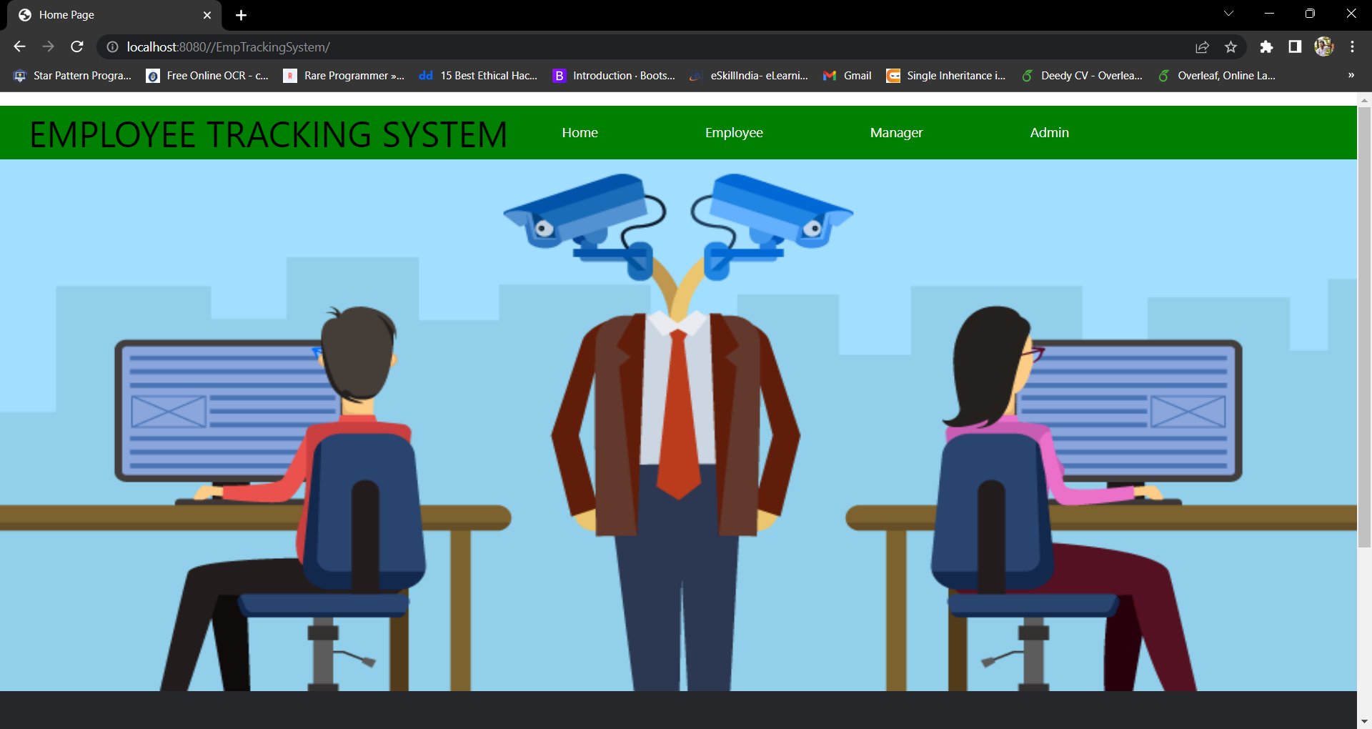

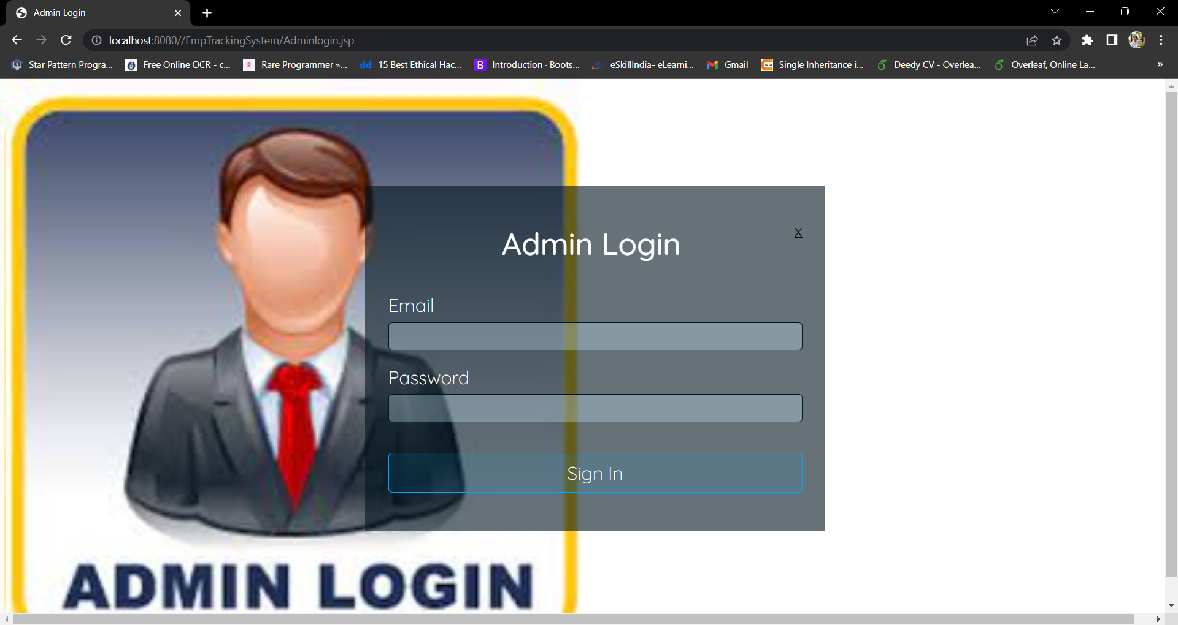

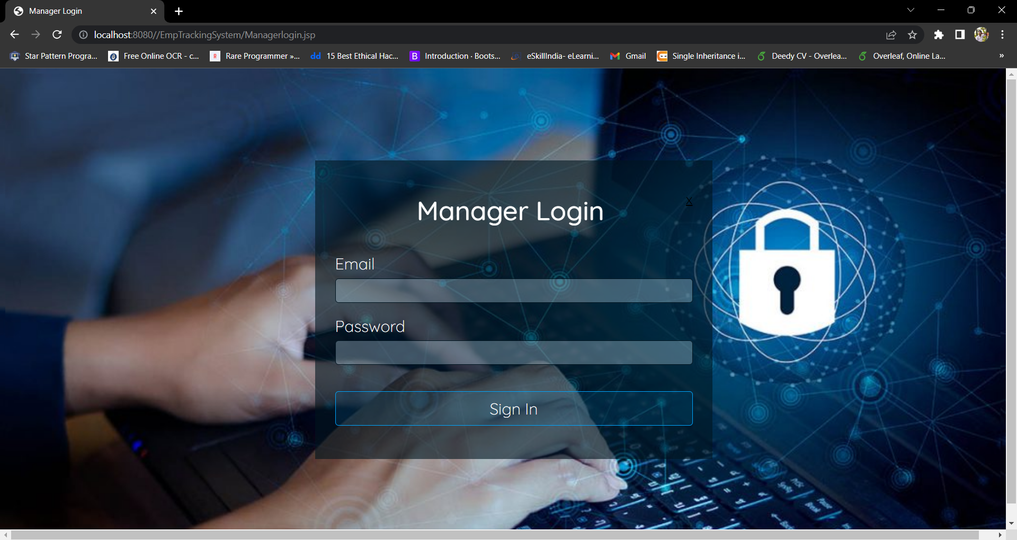

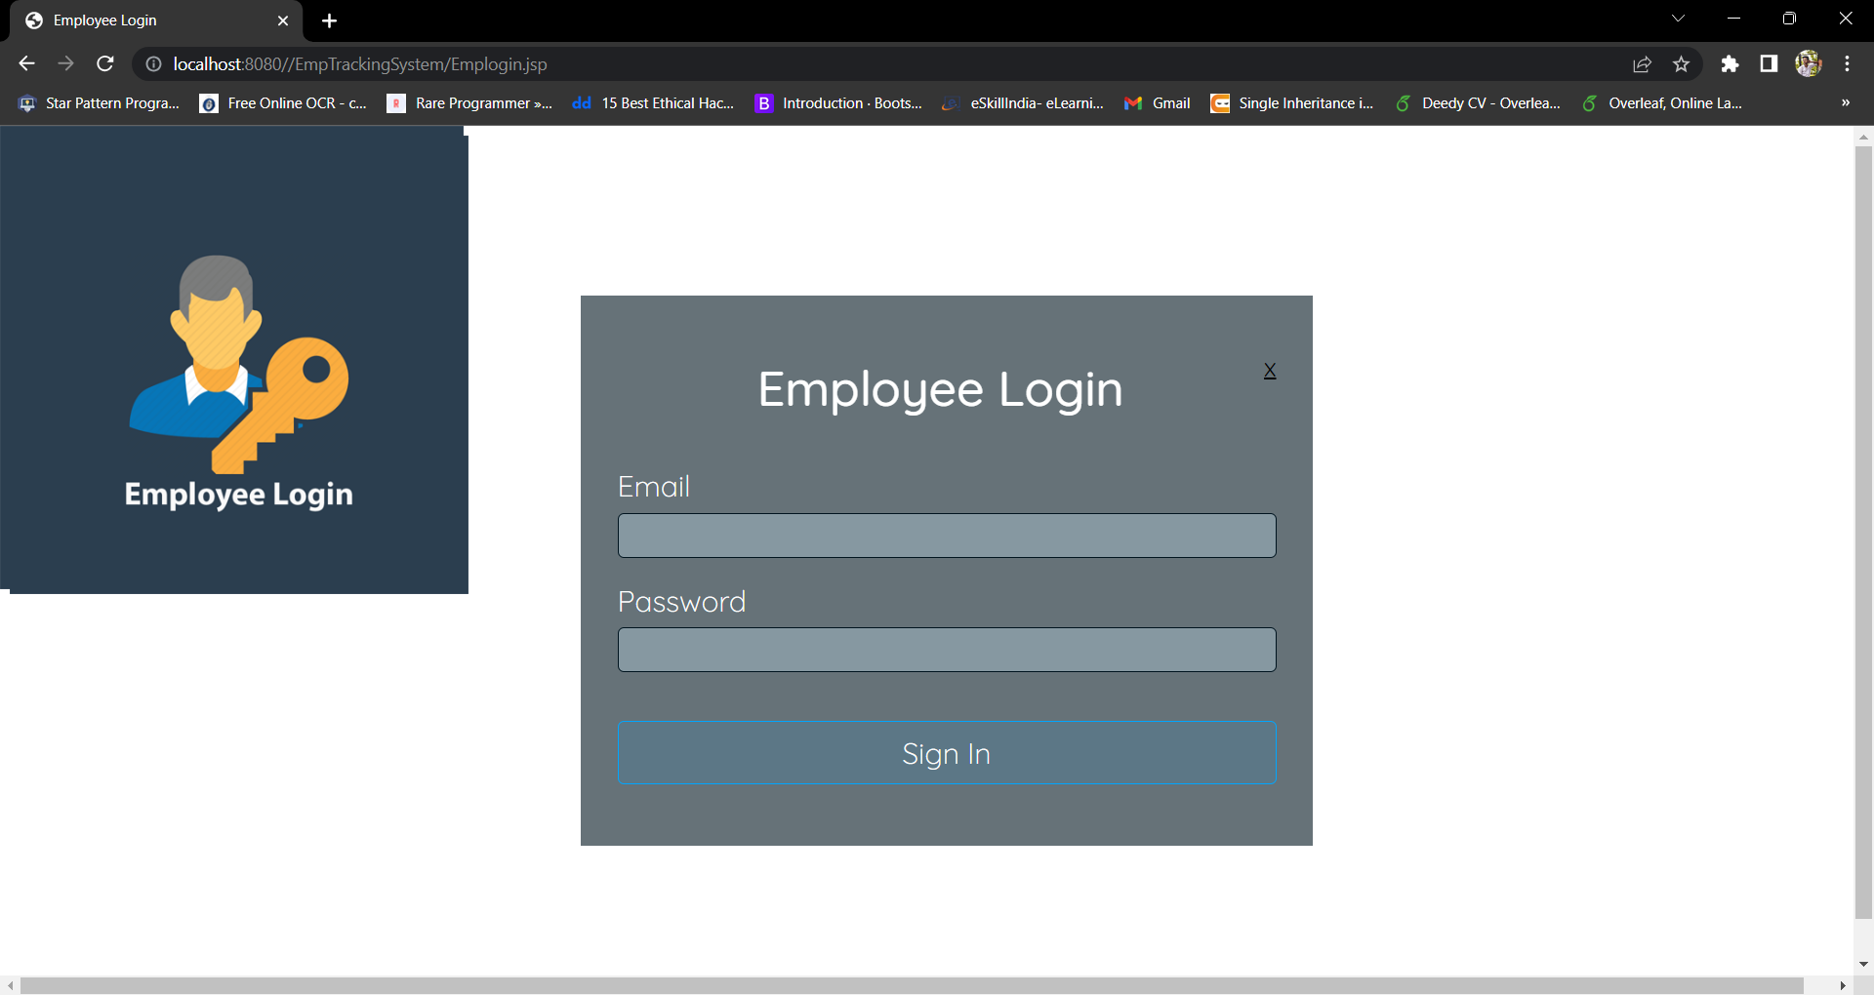

Admin Side

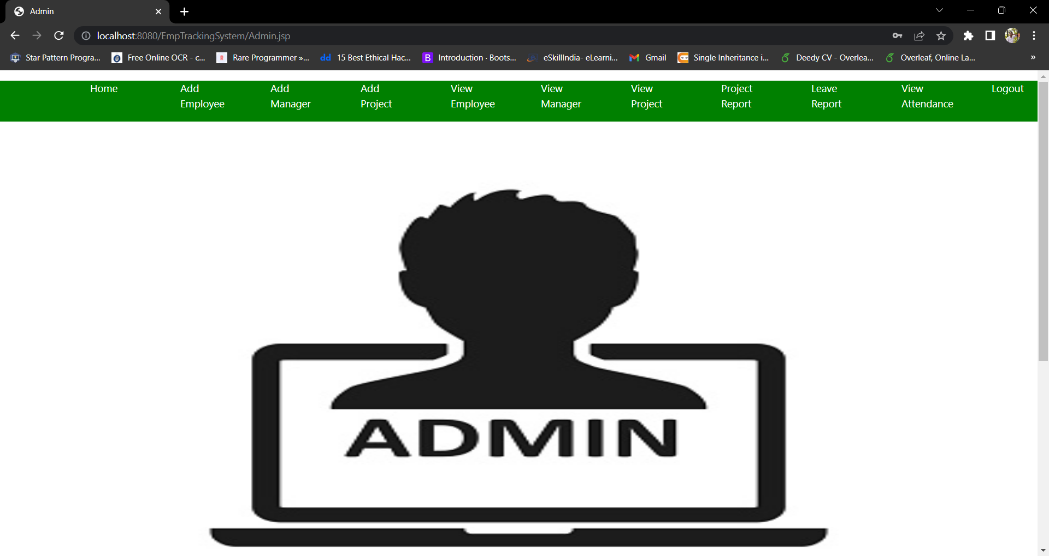

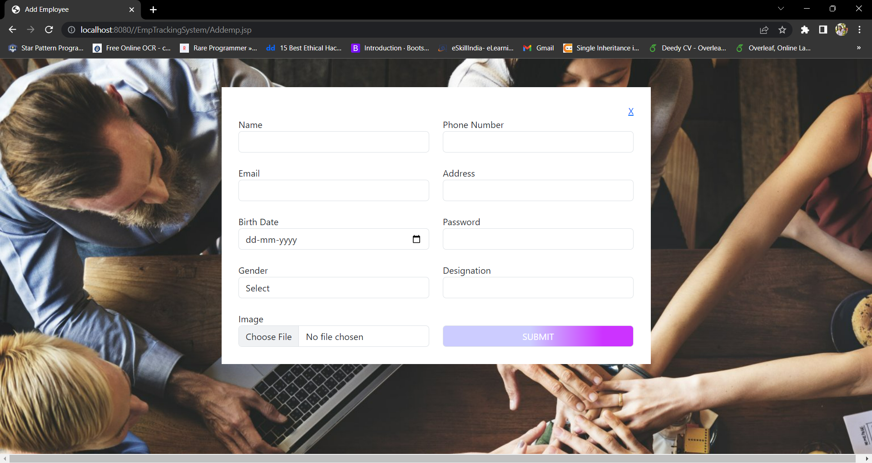

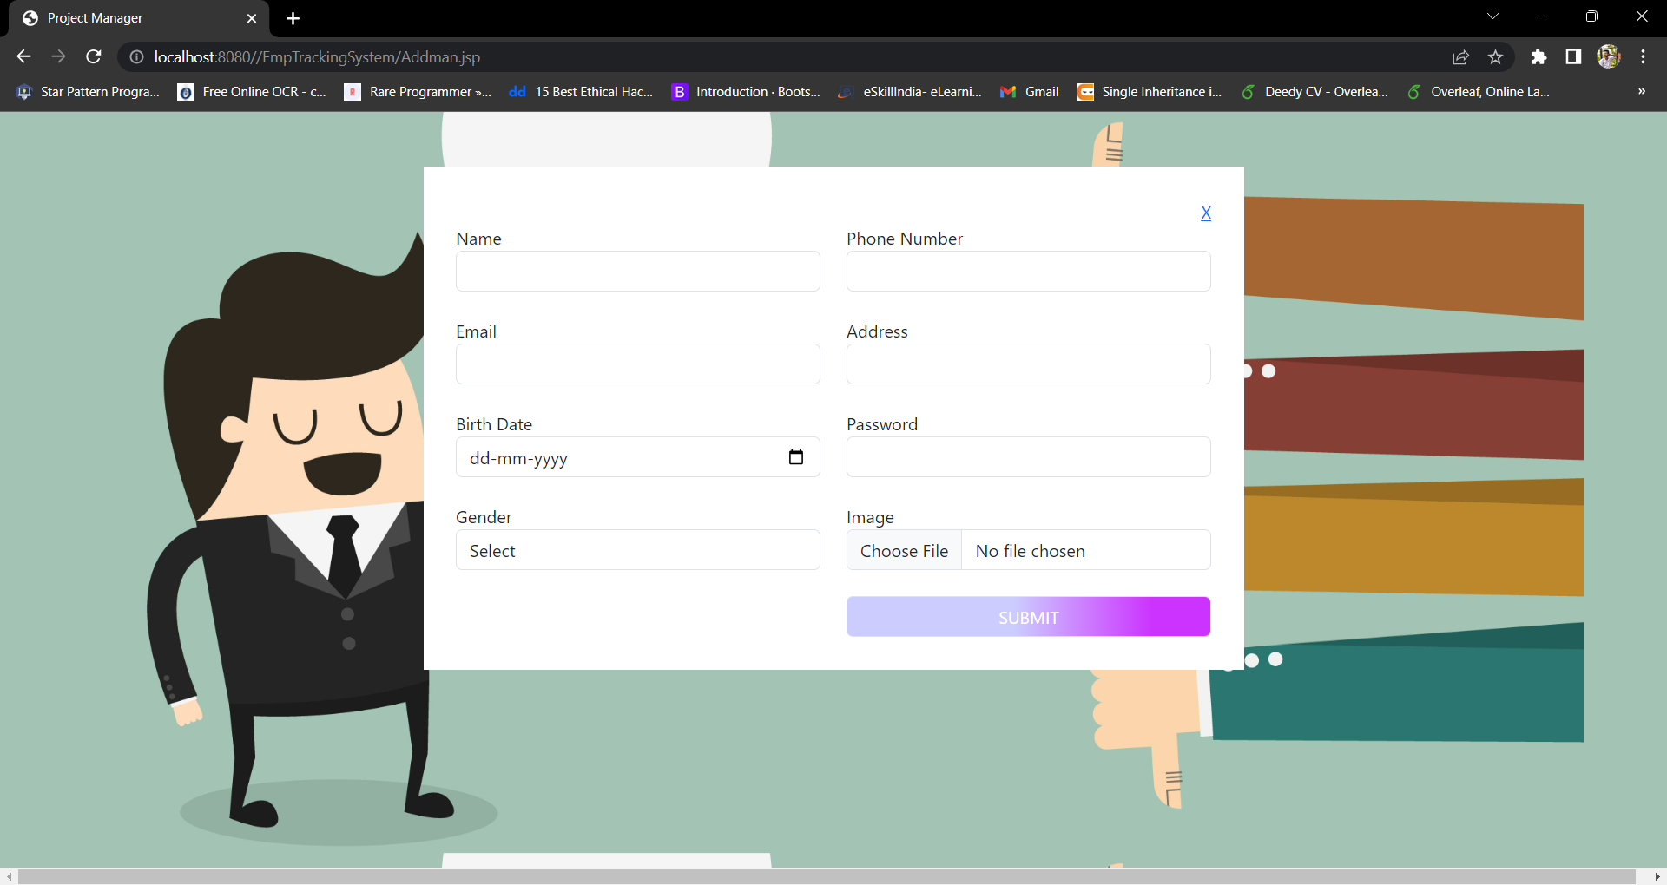

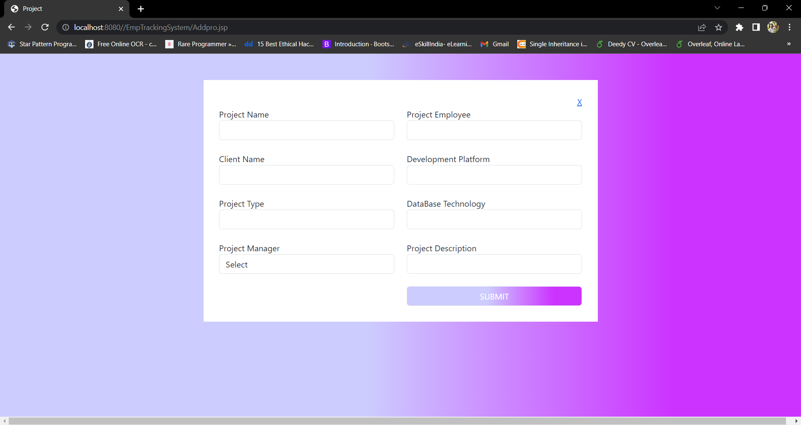

Manager

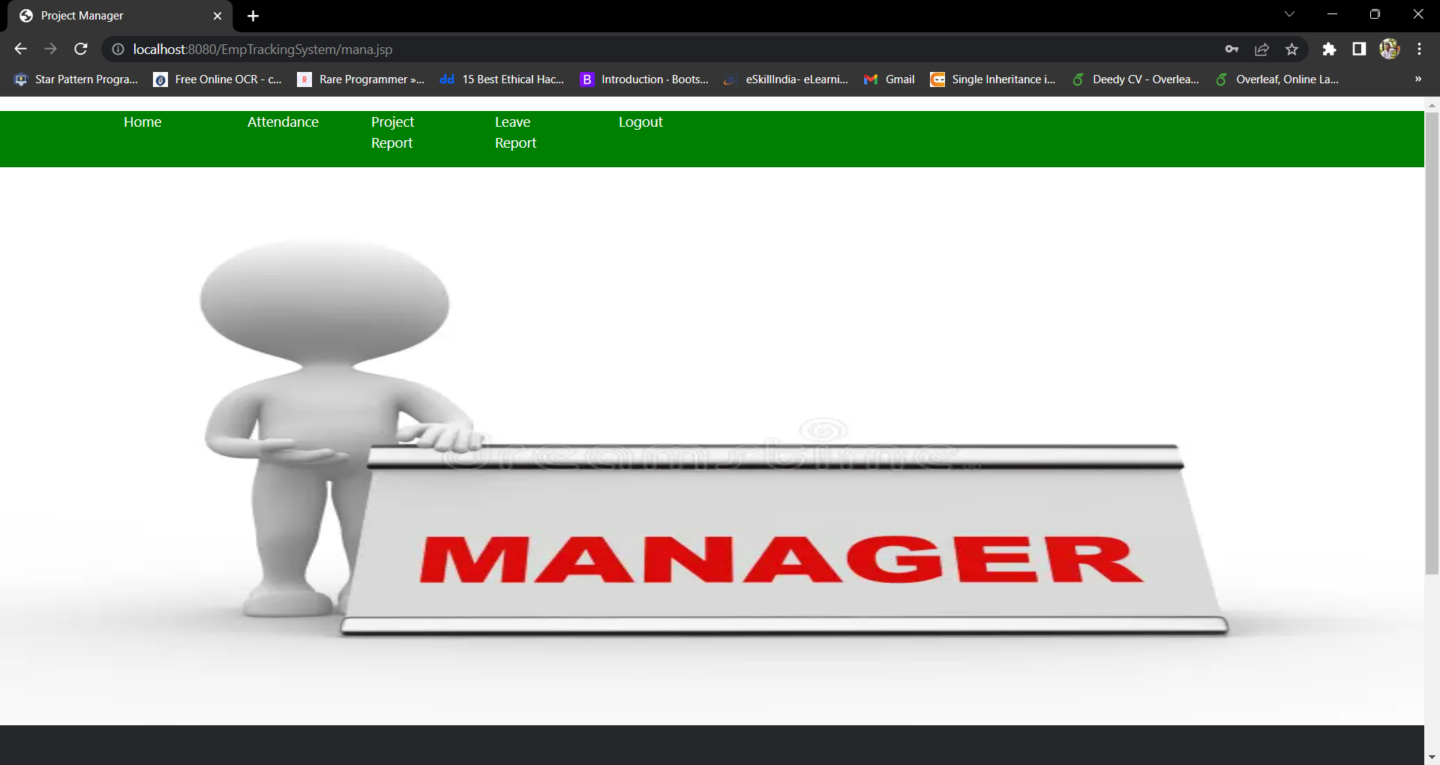

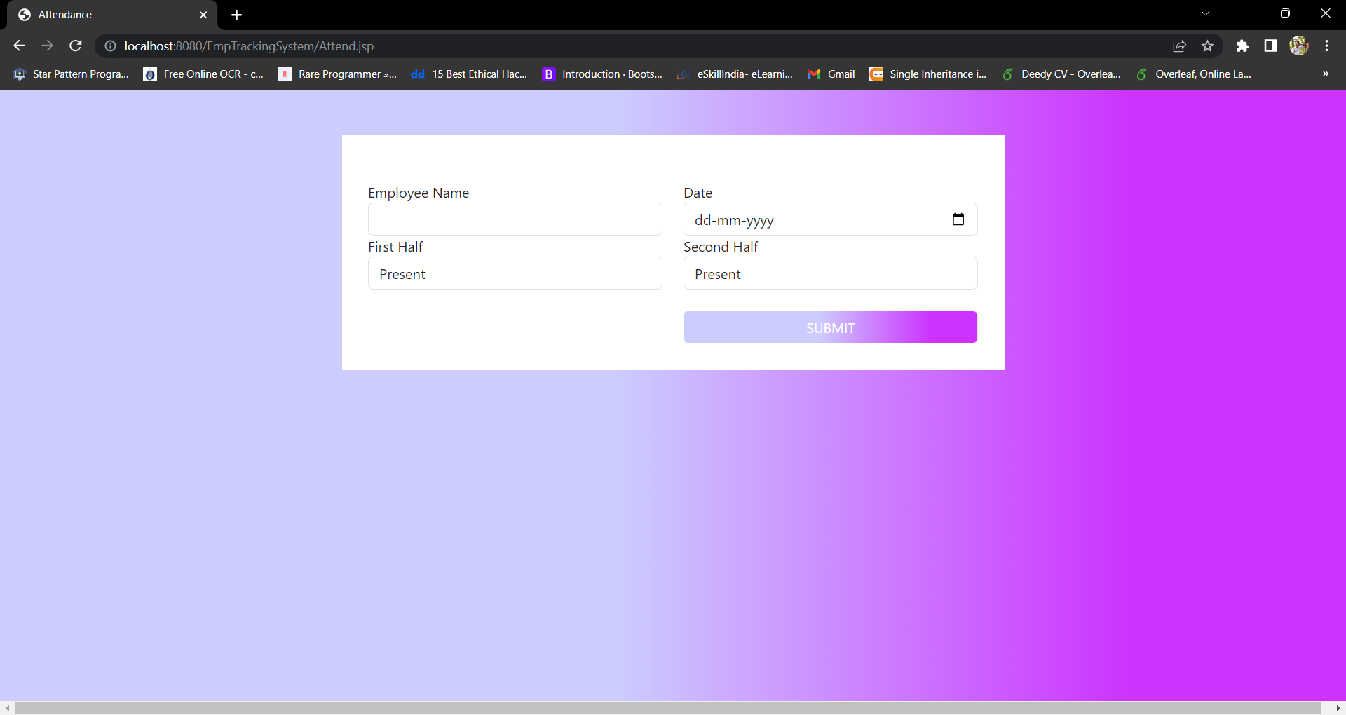

Employee :

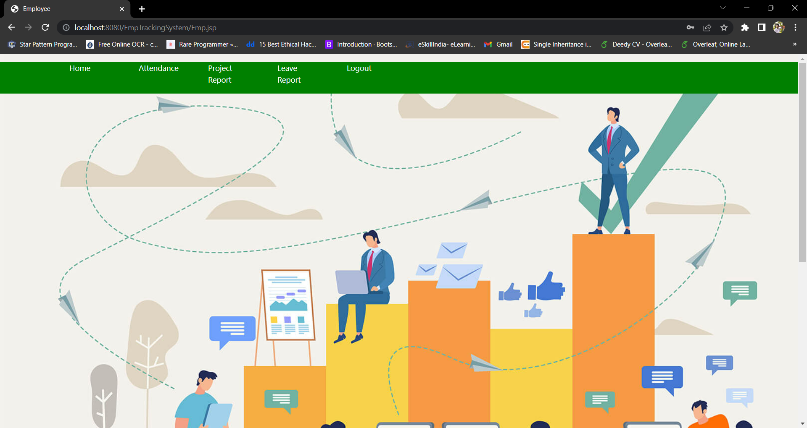



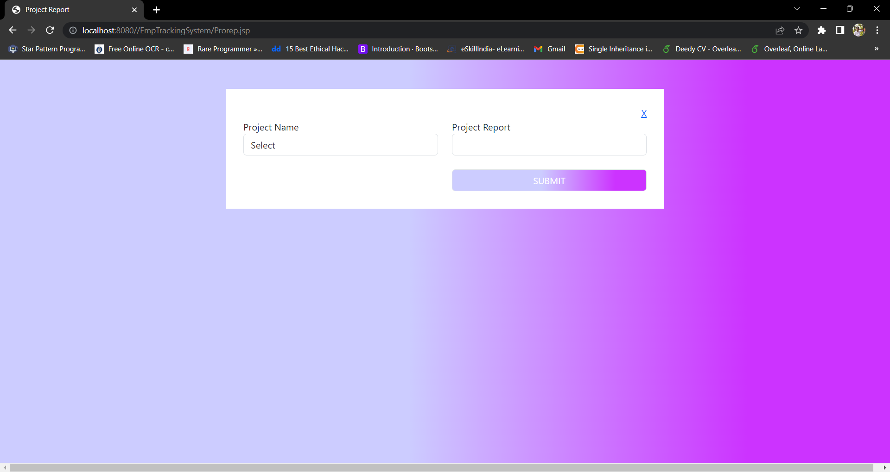

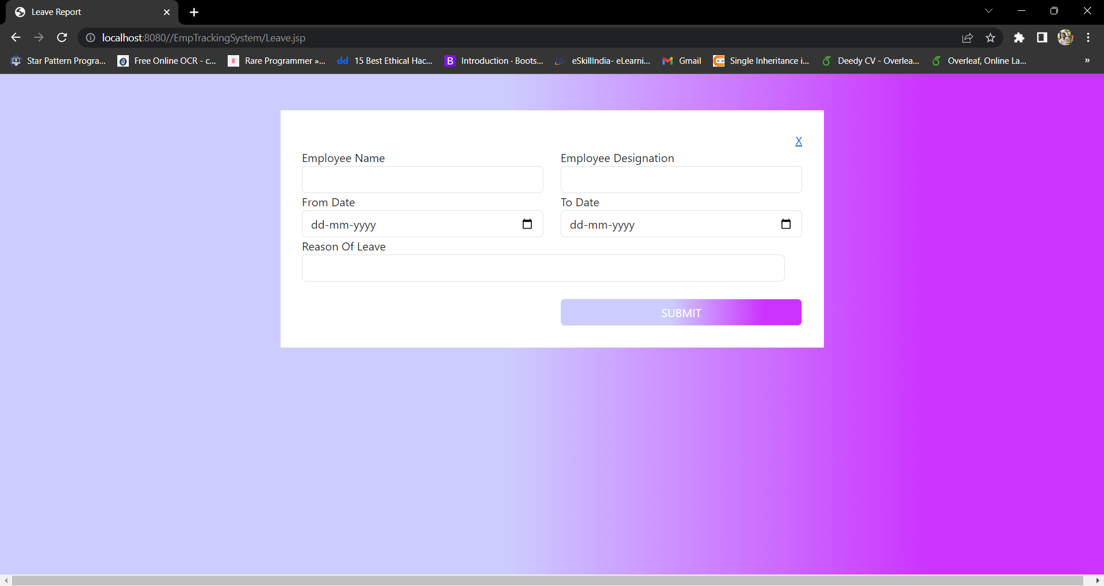

**REPORTS**

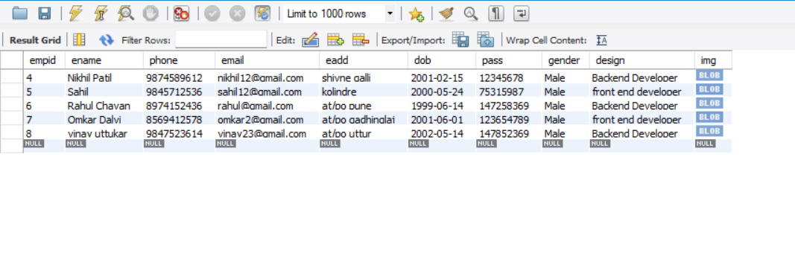

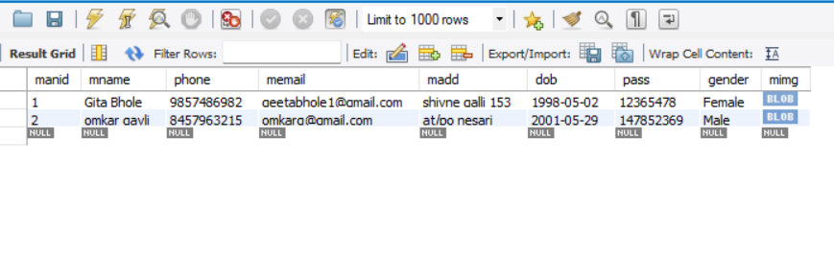

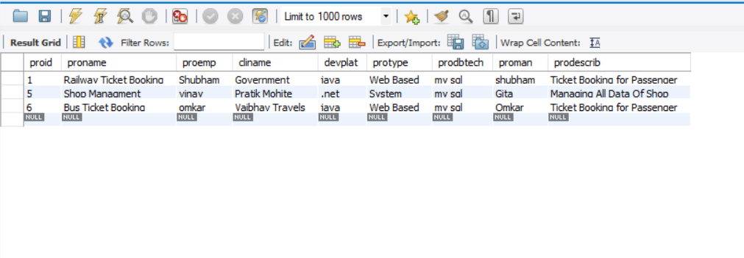

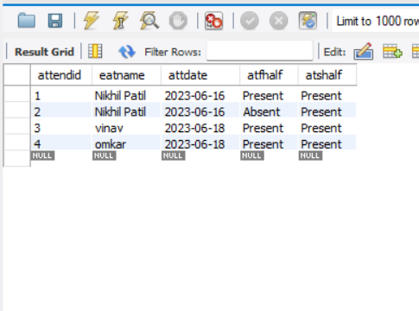

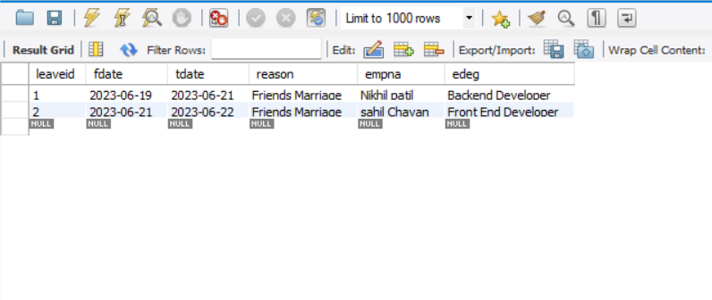

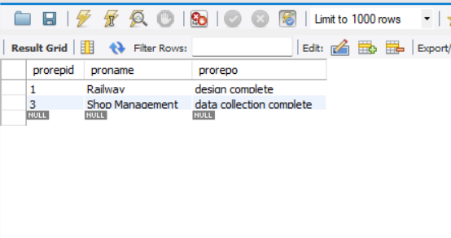

###### **LIMITATION**

* + - **Limitation of system**

1. User should have minimum (basic) knowledge about computer to handle the software.
2. User should be trained for handling the system and interact with the various facilities provided in it.
3. Maintenance cost of expensive.
4. Only a trained user can handle the system.

**CONCLUSION**

After designing and implementation of this system we have come to the following conclusion.

1. Due to computerization we can easily update, deletes or insert the data of user and hence retrieval of any record that is stored becomes easier.
2. Due to computerization, a lot of time is saved because all the paper work can be done on computer with greater accuracy.
3. Changes can be made immediately and efficiently as we require.
4. print- out of updated records can be taken.
5. Due to computerization department can maintain information of student/staff easily in the computer itself.

**Suggestion**

To overcome the limitation of the system there are some suggestions-

1. For user information & according addition of new module is required.
2. For better accuracy, correctly inputting data is required.

#### **BIBLIOGRAPHY**



Websites :

* [**www.google.com**](http://www.google.com/)

[www.wikipedia.com](http://www.wikipedia.com/)

* **Youtube Channels :**

1. Code with harry
2. Clever Programmer
3. Freecodecamp.org

**Books :**

1. Head first java

Author : Kathy Sierra & Bert Bates

1. Java : A Beginners guide

Author : Herbert schildt